**ANALISA STRUKTUR 2**

Mencari Bidang Momen, Lintang dan Normal Tahap 1, 2 dan 3 Continuous Beam

Dosen Pengampu:

Ir. H. AlMufid



Oleh

Rizik Ricky Ardi

1822201043

TEKNIK SIPIL

FAKULTAS TEKNIK

UNIVERSITAS MUHAMMADIYAH TANGERANG

2019/2020

**GAMBAR NOMOR 1**

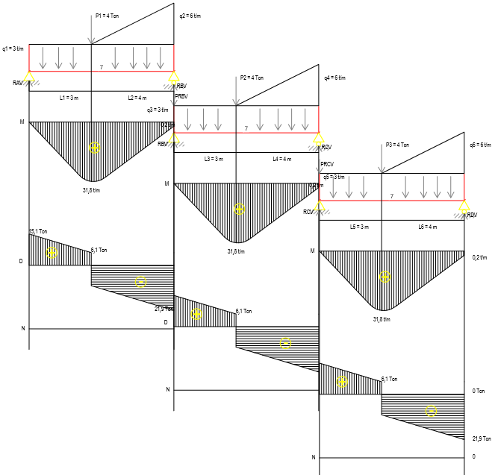

X = 3 m q1=q3=q5 = 3 t/m L1=L3=L5 = 3 m

Y = 4 m q2=q4=q6 = 6 t/m L2=L4=L6 = 4 m

P1=P2=P3 = 4 Ton

**NOMOR 1**

**(TAHAP 1)**

∑**MB** = **0**

RAV . LTOTAL – P1 . L2 – (q1 .LTOTAL) .. LTOTAL – ( . q2 . L2) .. L2 = 0

RAV . 7 – 4.4 – (3.7) . $\frac{1}{2}$. 7 – ( $\frac{1}{2}$. 6 .4) . $\frac{1}{3 } . 4$ = 0

RAV . 7 – 16 – 73,5 – 16 = 0

RAV . 7 – 105,5 = 0

RAV . 7 = 105,5

RAV = $\frac{105,5}{7}$

RAV = **15,1 ton**

∑**MA** = **0**

– RBV . LTOTAL + (. q2 . L2) . ( . L2 + L1) + P1 . L1 + (q1 . LTOTAL ) . . LTOTAL = 0

–RBV . 7 + ( $\frac{1}{2}$. 6 . 4) . ( $\frac{2}{3}$. 4 + 3) + 4 . 3 + (3 . 7) . $\frac{1}{2}$. 7 = 0

– RBV . 7 + 68 + 12 + 73,5 = 0

– RBV . 7 + 153,5 = 0

– RBV . 7 = – 153,5

RBV = $\frac{- 153,5}{–7}$

RBV = **21,9 ton**

**KONTROL**

**∑V = 0**

RAV – ( q1 . LTOTAL + . q2 . L2 + P1) + RBV = 0

15,1 – (3 .7 + $\frac{1}{2}$. 6 . 4 + 4) + 21,9 = 0

15,1 – 37 + 21,9 = 0

**0 = 0**

**BIDANG MOMEN (M)**

**Interval 0 ≤ X0 ≤ 0**

MXX – X0 = RAV . X0

= 15,1. 0 = **0 tm1**

**Interval 0 ≤ X1 ≤ L3 (3)**

MXX – X1 = RAV . X1 – (q1 . X1) . . X­­1

X1 = 3 = 15,1 . 3 – (3 . 3) . 3

= 45,3 – 13,5

= **31,8 tm1**

**Interval 0 ≤ X2 ≤ 7**

MXX – X2 = RAV . X2 – (q1 . X2) . . X2 – P1 . L2 – ( . q1 . L2) . L2

X2 = 7 = 15,1 . 7 – (3 . 7) . 7 – 4 . 4 – (. 6 . 4) $\frac{1}{3}$. 4

= 105,7 – 73,5 – 16 – 16

= **0,2 tm1**

**BIDANG LINTANG (D)**

**Interval 0 ≤ X0 ≤ 0**

X0 = 0

DXX – X0 = RAV

= **15,1 Ton**

**Interval 0 ≤ X1 ≤ L3 (3)**

DXX – X1 = RAV – q1. X1

**X1 = 3** = 15,1 – 3 . 3

= 15,1 – 9

= **6,1 Ton**

**Interval 0 ≤ X1 ≤ 7**

DXX – X2 = RAV’ – (q1 . X2) – P1– ( . q2 . L2)

**X2 = 7** = 15,1 – (3 . 7) – 4 – ( $\frac{1}{2}$. 6 . 4)

= 15,1 – 21 – 4 – 12

= **– 21,9 ton**

**BIDANG NORMAL (N)**

N = 0

**(TAHAP 2)**

∑**MC** = **0**

RBV’ . LTOTAL – PRBV . LTOTAL – P2 . L4 – (q3 .LTOTAL) .. LTOTAL – ( . q4 . L4) .. L4 = 0

RBV’ . 7 – 21,9 . 7 – 4 .4 – (3.7) . $\frac{1}{2}$. 7 – ( $\frac{1}{2}$. 6 .4) . $\frac{1}{3 } . 4$ = 0

RBV’ . 7 – 153,3 – 16 – 73,5 – 16 = 0

RBV’ . 7 – 153,3 – 16 – 73,5 – 16 = 0

RBV’ . 7 – 258,8 = 0

RBV’ . 7 = 258,8

RBV’ = $\frac{25,8}{7}$

**RBV’** = 37 **Ton**

∑**MB** = **0**

– RCV . LTOTAL + (. q4 . L4) ( . L4 + L3) + P2 . L3 + (q3 . LTOTAL ) . . LTOTAL = 0

–RCV . 7 + ( $\frac{1}{2}$. 6 . 4) . ( $\frac{2}{3}$. 4 + 3) + 4 . 3 + (3 . 7) . $\frac{1}{2}$. 7 = 0

– RCV . 7 + 68 + 12 + 73,5 = 0

– RCV . 7 + 153,5 = 0

– RCV . 7 = -153,5

RCV = $\frac{- 153,5}{–7}$

**RCV** = **21,9 ton**

**KONTROL**

**∑V = 0**

RBV’ – PRBV – q1 . LTOTAL – . q2 . L2 – P2 + RCV = 0

37– 21,9 – (3 .7) – ( . 6 . 4) – 4 + 21,9 = 0

37 – 21,9 – 21 – 12 – 4 + 21,9 = 0

**0 = 0**

**BIDANG MOMEN (M)**

**Interval 0 ≤ X0 ≤ 0**

MXX – X0 = RBV’ . X0

= 37. 0 = **0 tm1**

**Interval 0 ≤ X1 ≤ L3 (3)**

MXX – X1 = RBV’ . X1 – PRBV . X1 – (q3 . X1) . . X­­1

X1 = 3 = 37 . 3 – (21,9 . 3) – (3 . 3) . 3

= 111 – 65,7 – 13,5

= **31,8 tm1**

**Interval 0 ≤ X2 ≤ 7**

MXX – X2 = RBV’ . X2 – PRBV . X2 – (q3 . X2) . . X2 – P2 . L4 – ( . q4 . L4) . L4

X2 = 7 = 37 . 7 – (21,9 . 7) – (3 . 7) . 7 – 4 . 4 – (. 6 . 4) . 4

= 259 – 153,3 – 73,5 – 16 – 16

= **0,2 tm1**

**BIDANG LINTANG (D)**

**Interval 0 ≤ X0 ≤ 0**

X0 = 0

DXX – X0 = RBV’ – PRBV

= 37 – 21,9

= **15,1 Ton**

**Interval 0 ≤ X1 ≤ L3 (3)**

DXX – X1 = RBV’ – PRBV – q3. X1

**X1 = 3** = 37 – 21,9 – 3 . 3

= 37 – 21,9 – 9

= **6,1 Ton**

**Interval 0 ≤ X1 ≤ 7**

DXX – X2 = RBV’ – PRBV – (q3 . X2) – P2– ( . q4 . L4)

**X2 = 7** = 37 – 21,9 – (3 . 7) – 4 – ( $\frac{1}{2}$. 6 . 4)

= 37 – 21,9 – 21 – 4 – 12

= 15,1 – 21 – 4 – 12

= **– 21,9 ton**

**BIDANG NORMAL (N)**

N = 0

**(TAHAP 3)**

∑**MD** = **0**

RCV’ . LTOTAL – PRCV . LTOTAL – P3 . L6 – (q5 .LTOTAL) .. LTOTAL – ( . q6 . L6) .. L6 = 0

RCV’ . 7 – 21,9 . 7 – 4 .4 – (3.7) . $\frac{1}{2}$. 7 – ( $\frac{1}{2}$. 6 .4) . $\frac{1}{3 } . 4$ = 0

RCV’ . 7 – 153,3 – 16 – 73,5 – 16 = 0

RCV’ . 7 – 153,3 – 16 – 73,5 – 16 = 0

RCV’ . 7 – 258,8 = 0

RCV’ . 7 = 258,8

RCV’ = $\frac{25,8}{7}$

**RCV’** = 37 **Ton**

∑**MC** = **0**

– RDV . LTOTAL + (. q6 . L6) ( . L6 + L5) + P3 . L5 + (q5 . LTOTAL ) . . LTOTAL = 0

– RDV . 7 + ( $\frac{1}{2}$. 6 . 4) . ( $\frac{2}{3}$. 4 + 3) + 4 . 3 + (3 . 7) . $\frac{1}{2}$. 7 = 0

– RDV . 7 + 68 + 12 + 73,5 = 0

– RDV . 7 + 153,5 = 0

– RDV . 7 = -153,5

RDV = $\frac{- 153,5}{–7}$

**RDV** = **21,9 ton**

**KONTROL**

**∑V = 0**

RCV’ – PRCV – q5 . LTOTAL – . q6 . L6 – P5 + RDV = 0

37 – 21,9 – (3 .7) – ( . 6 . 4) – 4 + 21,9 = 0

37 – 21,9 – 21 – 12 – 4 + 21,9 = 0

**0 = 0**

**BIDANG MOMEN (M)**

**Interval 0 ≤ X0 ≤ 0**

MXX – X0 = RCV’ . X0

= 37. 0 = **0 tm1**

**Interval 0 ≤ X1 ≤ L3 (3)**

MXX – X1 = RCV’ . X1 – PRCV . X1 – (q5 . X1) . . X­­1

X1 = 3 = 37 . 3 – (21,9 . 3) – (3 . 3) . 3

= 111 – 65,7 – 13,5

= **31,8 tm1**

**Interval 0 ≤ X2 ≤ 7**

MXX – X2 = RCV’ . X2 – PRCV . X2 – (q5 . X2) . . X2 – P3 . L6 – ( . q6 . L6) . L6

X2 = 7 = 37 . 7 – (21,9 . 7) – (3 . 7) . 7 – 4 . 4 – (. 6 . 4) . 4

= 259 – 153,3 – 73,5 – 16 – 16

= **0,2 tm1**

**BIDANG LINTANG (D)**

**Interval 0 ≤ X0 ≤ 0**

X0 = 0

DXX – X0 = RCV’ – PRCV

= 37 – 21,9

= **15,1 Ton**

**Interval 0 ≤ X1 ≤ L3 (3)**

DXX – X1 = RCV’ – PRCV – q5. X1

**X1 = 3** = 37 – 21,9 – 3 . 3

= 37 – 21,9 – 9

= **6,1 Ton**

**Interval 0 ≤ X1 ≤ 7**

DXX – X2 = RCV’ – PRCV – (q5 . X2) – P3– ( . q6 . L6)

**X2 = 7** = 37 – 21,9 – (3 . 7) – 4 – ( $\frac{1}{2}$. 6 . 4)

= 37 – 21,9 – 21 – 4 – 12

= 15,1 – 21 – 4 – 12

= **– 21,9 ton**

**BIDANG NORMAL (N)**

N = 0

**GAMBAR NOMOR 3**

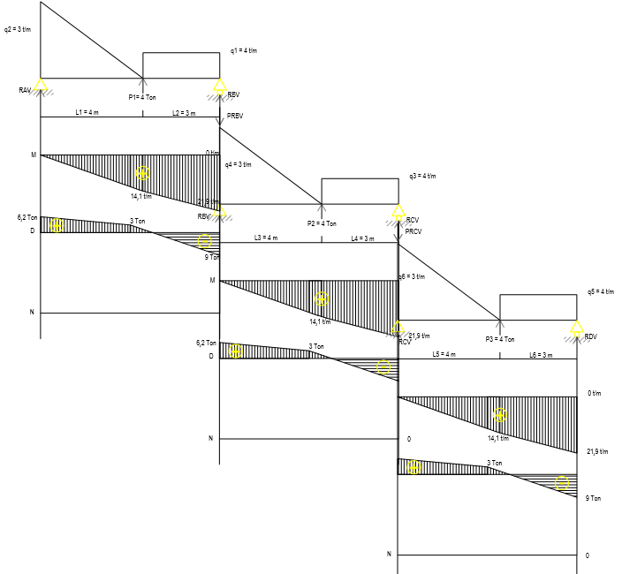

X = 3 m q1=q3=q5 = 4 t/m L1=L3=L5 = 4 m

Y = 4 m q2=q4=q6 = 3 t/m L2=L4=L6 = 3 m

P1=P2=P3 = 4 Ton

**NOMOR 3**

**(TAHAP 1)**

∑**MB** = **0**

RAV . LTOTAL – (. q2. L1) ( . L1 + L2) – (q1 .L2) .. L2 + P1 L2 = 0

RAV . 7 – (. 3 . 4) . ( $\frac{2}{3}$. 4 + 3) – (4.3) . $\frac{1}{2}$. 3 + 4 $\sin{45°}$ 3 = 0

RAV . 7 – 34 – 18 + 8,5 = 0

RAV . 7 – 34 – 18 + 8,5 = 0

RAV . 7 – 43,5 = 0

RAV. 7 = 43,5

RAV = $\frac{43,5}{7}$

RAV = **6,2 ton**

∑**MA** = **0**

– RBV . LTOTAL + (q1. L2) ( . L2 + L1) + ( . q2 . L1 ) ( . L1 ) – P1 L1 = 0

– RBV . 7 + (4 . 3) ( $\frac{1}{2}$. 3 + 4) + ( $\frac{1}{2}$. 3. 4) ( $\frac{1}{3}$. 4) – 4 $\sin{45°}$ 4 = 0

– RBV . 7 + 66 + 8 – 11,3 = 0

– RBV . 7 + 62,7 = 0

– RBV . 7 = –62,7

RBV = $\frac{- 62,7}{–7}$

RBV = **9 ton**

**KONTROL**

**∑V = 0**

RAV – (q1 . L2) – ( . q2 . L1) + P1  + RBV = 0

6,2 – (4 . 3) – ( $\frac{1}{2}$. 3 . 4) + 4. $\sin{45°}$ + 9 = 0

6,2 – 12 – 6 + 2,8 + 9 = 0

**0 = 0**

**BIDANG MOMEN (M)**

**Interval 0 ≤ X0 ≤ 0**

X0 = 0

MXX – X0 = RAV . X0

= 6,2 . 0 = **0 tm1**

**Interval 0 ≤ X1 ≤ L3 (4)**

MXX – X1 = RAV.X1 – ( . q2 . L1) + P1 . 4 – q2 .L1

**X1 = 4**  = 6,2 . 4 – (( . 3. 4) + 4 . 4 – 4 . 4

= 24,8 – 6 + 11,3 – 16

= **14,1 tm1**

**Interval 0 ≤ X2 ≤ 7**

MXX – X2 = RAV . X2 – ( . q2 . L1) . . L2 + P1 . L2 – (q1 . L2) . . L2

**X2 = 7**  = 6,2 . 7 – ( . 3. 4) . . 3 + 4 . 3 – (4 . 3) . . 3

= 43,4 – 12 + 8,5 – 18

**= 21,9 tm1**

**BIDANG LINTANG (D)**

**Interval 0 ≤ X0 ≤ 0**

X0 = 0

DXX – X0 = RAV

= **6,2 Ton**

**Interval 0 ≤ X1 ≤ L3 (4)**

DXX – X1 = RAV – ( . q2 . L3) + P1

**X1 = 3,5** = 6,2 – ( . 3. 4) + 4 $\sin{45°}$

= 6,2 – 6 + 2,8

= **3 Ton**

**Interval 0 ≤ X2 ≤ 7**

DXX – X1 = RAV – ( . q2 . L1) + P1 – (q1 . L2)

**X2 = 7** = 6,2 – ( . 3. 4) + 4 $\sin{45°}$– (4 . 3)

= 6,2 – 6 + 2,8 – 12

= **– 9 Ton**

**BIDANG NORMAL (N)**

N = 0

**(TAHAP 2)**

∑**MC** = **0**

RBV’ . LTOTAL – (PRBV) . LTOTAL – (. q4 . L3) ( . L3 + L4) – (q3 .L4) .. L4 + P2 L4 = 0

RBV’ . 7– (9 . 7) – ($\frac{1}{2}$. 3 . 4) . ( $\frac{2}{3}$. 4 + 3) – (4.3) . $\frac{1}{2}$. 3 + 4 $\sin{45°}$ 3 = 0

RBV’ . 7 – 63 – 34 – 18 + 8,5 = 0

RBV’ . 7 – 63 – 34 – 18 + 8,5 = 0

RBV’ . 7 – 106,5 = 0

RBV’. 7 = 106,5

RBV’ = $\frac{106,5}{7}$

RBV’ = **15,2 ton**

∑**MB** = **0**

– RCV . LTOTAL + (q3. L4) ( . L4 + L3) + ( . q4 . L3 ) ( . L3 ) – P2 L3 = 0

– RCV . 7 + (4 . 3) ( $\frac{1}{2}$. 3 + 4) + ( $\frac{1}{2}$. 3. 4) ( $\frac{1}{3}$. 4) – 4 $\sin{45°}$ 4 = 0

– RCV . 7 + 66 + 8 – 11,3 = 0

– RCV . 7 + 62,7 = 0

– RCV . 7 = –62,7

RCV = $\frac{- 62,7}{–7}$

RCV = **9 ton**

**KONTROL**

**∑V = 0**

RBV’ – PRBV – (q3 . L4) – ( . q4 . L3) + P2  + RCV = 0

15,2 – 9 – (4 . 3) – ( . 3 . 4) + 4. $\sin{45°}$ + 9 = 0

15,2 – 9 – 12 – 6 + 2,8 + 9 = 0

**0 = 0**

**BIDANG MOMEN (M)**

**Interval 0 ≤ X0 ≤ 0**

X0 = 0

MXX – X0 = RBV’ . X0

= 15,2 . 0 = **0 tm1**

**Interval 0 ≤ X1 ≤ L3 (4)**

MXX – X1 = RBV’.X1 – PRBV .X1 – ( . q4 . L3) + P2 . 4 – q4 .L3

**X1 = 4**  = 15,2 . 4 – (9 . 4) – (( . 3. 4) + 4 . 4 – 4 . 4

= 60,8 – 36 – 6 + 11,3 – 16

= **14,1 tm1**

**Interval 0 ≤ X2 ≤ 7**

MXX – X2 = RBV’ . X2 – PRBV .X2 – ( . q4 . L3) . . L4 + P2 . L4 – (q3 . L4) . . L4

**X2 = 7**  = 15,2 . 7 – (9 . 7 )– ( . 3. 4) . . 3 + 4 . 3 – (4 . 3) . . 3

= 106,4 – 63 – 12 + 8,5 – 18

**= 21,9 tm1**

**BIDANG LINTANG (D)**

**Interval 0 ≤ X0 ≤ 0**

X0 = 0

DXX – X0 = RBV’ – PRBV

= 15,2 – 9

= **6,2 Ton**

**Interval 0 ≤ X1 ≤ L3 (4)**

DXX – X1 = RBV’ – PRBV – ( . q4 . L3) + P2

**X1 = 3,5** = 15,2 – 9 – ( . 3. 4) + 4

= 15,2 – 9 – 6 + 2,8

= **3 Ton**

**Interval 0 ≤ X2 ≤ 7**

DXX – X1 = RBV’ – PRBV – ( . q4 . L3) + P2 – (q3 . L4)

**X2 = 7** = 15,2 – 9 – ( . 3. 4) + 4 $\sin{45°}$– (4 . 3)

= 15,2 – 9 – 6 + 2,8 – 12

= **– 9 Ton**

**BIDANG NORMAL (N)**

N = 0

**(TAHAP 3)**

∑**MD** = **0**

RCV’ . LTOTAL – (PRCV) . LTOTAL – (. q6 . L5) ( . L5 + L6) – (q5 .L6) .. L6 + P3 L6 = 0

RCV’ . 7– (9 . 7) – ($\frac{1}{2}$. 3 . 4) . ( $\frac{2}{3}$. 4 + 3) – (4.3) . $\frac{1}{2}$. 3 + 4 $\sin{45°}$ 3 = 0

RCV’ . 7 – 63 – 34 – 18 + 8,5 = 0

RCV’ . 7 – 63 – 34 – 18 + 8,5 = 0

RCV’ . 7 – 106,5 = 0

RCV’. 7 = 106,5

RCV’ = $\frac{106,5}{7}$

RCV’ = **15,2 ton**

∑**MC** = **0**

– RDV . LTOTAL + (q5. L6) ( . L6 + L5) + ( . q6 . L5 ) ( . L5 ) – P3 L5 = 0

– RDV . 7 + (4 . 3) ( $\frac{1}{2}$. 3 + 4) + ( $\frac{1}{2}$. 3. 4) ( $\frac{1}{3}$. 4) – 4 $\sin{45°}$ 4 = 0

– RDV . 7 + 66 + 8 – 11,3 = 0

– RDV . 7 + 62,7 = 0

– RDV . 7 = –62,7

RDV = $\frac{- 62,7}{–7}$

RDV = **9 ton**

**KONTROL**

**∑V =**

RCV’ – PRCV – (q5 . L6) – ( . q6 . L5) + P3  + RDV = 0

15,2 – 9 – (4 . 3) – ( . 3 . 4) + 4. $\sin{45°}$ + 9 = 0

15,2 – 9 – 12 – 6 + 2,8 + 9 = 0

**0 = 0**

**BIDANG MOMEN (M)**

**Interval 0 ≤ X0 ≤ 0**

X0 = 0

MXX – X0 = RCV’ . X0

= 15,2 . 0 = **0 tm1**

**Interval 0 ≤ X1 ≤ L3 (4)**

MXX – X1 = RCV’.X1 – PRCV .X1 – ( . q6 . L5) + P3 . 4 – q6 .L5

**X1 = 4**  = 15,2 . 4 – (9 . 4) – (( . 3. 4) + 4 . 4 – 4 . 4

= 60,8 – 36 – 6 + 11,3 – 16

= **14,1 tm1**

**Interval 0 ≤ X2 ≤ 7**

MXX – X2 = RCV’ . X2 – PRCV .X2 – ( . q6. L5) . . L6 + P3 . L6 – (q5 . L6) . . L6

**X2 = 7**  = 15,2 . 7 – (9 . 7 )– ( . 3. 4) . . 3 + 4 . 3 – (4 . 3) . . 3

= 106,4 – 63 – 12 + 8,5 – 18

**= 21,9 tm1**

**BIDANG LINTANG (D)**

**Interval 0 ≤ X0 ≤ 0**

X0 = 0

DXX – X0 = RCV’ – PRCV

= 15,2 – 9

= **6,2 Ton**

**Interval 0 ≤ X1 ≤ L3 (4)**

DXX – X1 = RCV’ – PRCV – ( . q6 . L5) + P3

**X1 = 3,5** = 15,2 – 9 – ( . 3. 4) + 4

= 15,2 – 9 – 6 + 2,8

= **3 Ton**

**Interval 0 ≤ X2 ≤ 7**

DXX – X1 = RCV’ – PRCV – ( . q6 . L5) + P3 – (q5 . L6)

**X2 = 7** = 15,2 – 9 – ( . 3. 4) + 4 $\sin{45°}$– (4 . 3)

= 15,2 – 9 – 6 + 2,8 – 12

= **– 9 Ton**

**BIDANG NORMAL (N)**

N = 0

**GAMBAR NOMOR 5**

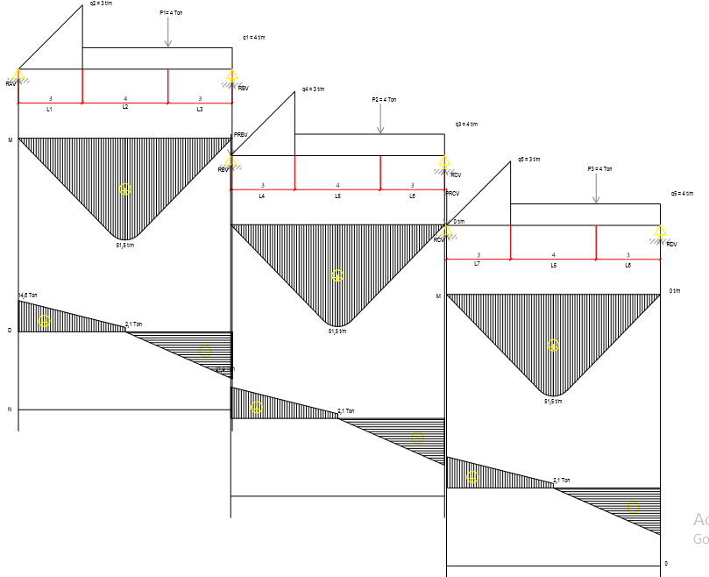

X = 3 m q1=q3=q5 = 4 t/m L1=L4=L7 = 3 m

Y = 4 m q2=q4=q6 = 3 t/m L2=L5=L8 = 4 m

P1=P2=P3 = 4 Ton L3=L6=L9 = 3 m

**NOMOR 5**

**(TAHAP 1)**

∑**MB** = **0**

RAV. LTOTAL – (q2 . L1) ( . L1 + L2 + L3) – P1 . L3 – (q1 (L2+ L3)) . (L2+ L3) = 0

RAV. 10 – ($\frac{1}{2}$. 3 . 3) . ( $\frac{1}{3}$. 3 + 4+ 3) – 4 . 3– (4(4+ 3)) . $\frac{1}{2}$ (4 + 3) = 0

RAV. 10 – 36 – 12 – 98 = 0

RAV. 10 – 146 = 0

RAV. 10 = 146

RAV = $\frac{146}{10}$

**RAV**  = **14,6 ton**

∑**MA** = **0**

– RBV . LTOTAL + (q1 (L2+ L3)) . (L2+ L3)+ L1 ) + P1 ((L2+ L1 ) +(. q2 . L1) . .L1 = 0

– RBV . 10 + (4(4 + 3)) . $( \frac{1}{2}$ (4 + 3)+ 3 ) + 4 ((4+ 3) +($\frac{1}{2}$. 3 . 3). $\frac{2}{3}$.3 = 0

– RBV . 10 + 182 + 28 + 9 = 0

– RBV . 10 + 219 = 0

– RBV . 10 = – 219

RBV = $\frac{- 219}{–10}$

**RBV** = **21,9 ton**

**KONTROL**

**∑V = 0**

RAV – q1(L2 + L3) – ( . q2 . L1) – P1 + RBV = 0

14,6 – (4.(4 + 3 ) – ( $\frac{1}{2}$. 3 . 3) – 4 + 21,9 = 0

14,6 – 28 – 4,5 – 4 + 21,9 = 0

**0 = 0**

**BIDANG MOMEN (M)**

**Interval 0 ≤ X0 ≤ 0**

MXX – X0 = RAV . X0

= 14,6 . 0 = **0 tm1**

**Interval 0 ≤ X1 ≤ L (5)**

MXX – X1 = RAV . X1 – ( . q2 . L3) . . L3 + 2 – (q1 . 2) . . 2

**X1 = 5** = 14,6 . 5 – ( . 3. 3) . . 3 + 2 – (4 . 2) . . 2

= 73 – 13,5 – 8

= **51,5 tm1**

**Interval 0 ≤ X2 ≤ 10**

MXX – X2 = RAV . X2 – ( . q2 . L1) . . L1 + 7 – P1 . L3 – (q1 . 7) . . 7

= 14,6 . 10 – ( . 3. 3) . . 3 + 7 – 4 . 3 – (4 . 7) . $\frac{1}{2}$. 7

= 146 – 36 – 12 – 98

= **0 tm1**

**BIDANG LINTANG (L)**

**Interval 0 ≤ X0 ≤ 0**

X0 = 0

DXX – X0 = RAV

= **14,6 Ton**

**Interval 0 ≤ X1 ≤ L (5)**

DXX – X1 = RAV – ( . q2 . L1) – (q1 . 2)

**X1 = 5** = 14,6 – ( . 3. 3) – (4 . 2)

= 14,6 – 4,5 – 8

= **2,1 ton**

**Interval 0 ≤ X2 ≤ 10**

DXX – X1 = RAV **–** ( . q2 . L1) – P1 – (q1 . 7)

**X2 = 10** = 14,6 **–** ( . 3. 3) – 4– (4 . 7)

= 14,6 – 4,5 – 4 – 28

= **– 21,9 ton**

**BIDANG NORMAL (N)**

N = 0

**(TAHAP 2)**

∑**MC** = **0**

RBV’. LTOTAL – (PRBV) . LTOTAL – (q4 . L4) ( . L4 + L5 + L6) – P2 . L6 – (q3 (L5+ L6)) . (L5+ L6) = 0

RBV’. 10 – (21,9 . 10) – ($\frac{1}{2}$. 3 . 3) . ( $\frac{1}{3}$. 3 + 4+ 3) – 4 . 3– (4(4+ 3)) . $\frac{1}{2}$ (4 + 3) = 0

RBV’. 10 – 219 – 36 – 12 – 98 = 0

RBV’. 10 – 219 – 36 – 12 – 98 = 0

RBV’. 10 – 365 = 0

RBV’. 10 = 365

RBV’ = $\frac{365}{10}$

**RBV’**  = **36,5 ton**

∑**MB** = **0**

– RCV . LTOTAL + (q3 (L5+ L6)) . (L5+ L6)+ L4 ) + P2 ((L5+ L4 ) +(. q4 . L4) . .L4 = 0

– RCV . 10 + (4(4 + 3)) . $( \frac{1}{2}$ (4 + 3)+ 3 ) + 4 ((4+ 3) +($\frac{1}{2}$. 3 . 3). $\frac{2}{3}$.3 = 0

– RCV . 10 + 182 + 28 + 9 = 0

– RCV . 10 + 219 = 0

– RCV . 10 = – 219

RCV = $\frac{- 219}{–10}$

**RCV** = **21,9 ton**

**KONTROL**

**∑V = 0**

RBV’ – PRBV – q3(L5 + L6 ) – ( . q4 . L4) – P2 + RCV = 0

36,5 – 21,9 – (4.(4 + 3 ) – ( $\frac{1}{2}$. 3 . 3) – 4 + 21,9 = 0

36,5 – 21,9 – 28 – 4,5 – 4 + 21,9 = 0

**0 = 0**

**BIDANG MOMEN (M)**

**Interval 0 ≤ X0 ≤ 0**

MXX – X0 = RBV’ . X0

= 36,5 . 0 = **0 tm1**

**Interval 0 ≤ X1 ≤ L (5)**

MXX – X1 = RBV’ . X1 – PRBV . X1 – ( . q4 . L6) . . L6 + 2 – (q3 . 2) . . 2

**X1 = 5** = 36,5 . 5 – (21,9 . 5) – ( . 3. 3) . . 3 + 2 – (4 . 2) . . 2

= 182,5 – 109,5 – 13,5 – 8

= **51,5 tm1**

**Interval 0 ≤ X2 ≤ 10**

MXX – X2 = RBV’ . X2 – PRBV . X2 – ( . q4 . L4) . . L4 + 7 – P2 . L6 – (q3 . 7) . . 7

= 36,5 . 10 – (-21,9) . 10– ( . 3. 3) . . 3 + 7 – 4 . 3 – (4 . 7) . . 7

= 365 – 219 – 36 – 12 – 98

= **0 tm1**

**BIDANG LINTANG (L)**

**Interval 0 ≤ X0 ≤ 0**

X0 = 0

DXX – X0 = RBV’ **–** PRBV

= 36,5 – 21,9

= **14,6 Ton**

**Interval 0 ≤ X1 ≤ L (5)**

DXX – X1 = RBV’ **–** PRBV – ( . q4 . L4) – (q3 . 2)

**X1 = 5** = 36,5 – 21,9 – ( . 3. 3) – (4 . 2)

= 36,5 – 21,9– 4,5 – 8

= **2,1 ton**

**Interval 0 ≤ X2 ≤ 10**

DXX – X1 = RBV’ **–** PRBV – ( . q4 . L4) – P2 – (q3 . 7)

**X2 = 10** = 36,5 – 21,9 **–** ( $\frac{1}{2}$. 3. 3) – 4– (4 . 7)

= 36,5 – 21,9 – 4,5 – 4 – 28

= **– 21,9 ton**

**BIDANG NORMAL (N)**

N = 0

**(TAHAP 3)**

∑**MD** = **0**

RCV’. LTOTAL – (PRCV) . LTOTAL – (q6 . L7) ( . L7 + L8 + L9) – P3 . L9 – (q5 (L8+ L9)) . (L8+ L9) = 0

RCV’. 10 – (21,9 . 10) – ($\frac{1}{2}$. 3 . 3) . ( $\frac{1}{3}$. 3 + 4+ 3) – 4 . 3– (4(4+ 3)) . $\frac{1}{2}$ (4 + 3) = 0

RCV’. 10 – 219 – 36 – 12 – 98 = 0

RCV’. 10 – 219 – 36 – 12 – 98 = 0

RCV’. 10 – 365 = 0

RCV’. 10 = 365

RCV’ = $\frac{365}{10}$

**RCV’**  = **36,5 ton**

∑**MC** = **0**

– RDV . LTOTAL + (q5 (L8+ L9)) . (L8+ L9)+ L7 ) + P3 ((L8+ L7 ) +(. q6 . L7) . .L7 = 0

– RDV . 10 + (4(4 + 3)) . $( \frac{1}{2}$ (4 + 3)+ 3 ) + 4 ((4+ 3) +($\frac{1}{2}$. 3 . 3). $\frac{2}{3}$.3 = 0

– RDV . 10 + 182 + 28 + 9 = 0

– RDV . 10 + 219 = 0

– RDV . 10 = – 219

RDV = $\frac{- 219}{–10}$

**RDV** = **21,9 ton**

**KONTROL**

**∑V = 0**

RCV’ – PRCV – q5(L8 + L9 ) – ( . q6 . L7) – P3 + RDV = 0

36,5 – 21,9 – (4.(4 + 3 ) – ( $\frac{1}{2}$. 3 . 3) – 4 + 21,9 = 0

36,5 – 21,9 – 28 – 4,5 – 4 + 21,9 = 0

**0 = 0**

**BIDANG MOMEN (M)**

**Interval 0 ≤ X0 ≤ 0**

MXX – X0 = RCV’ . X0

= 36,5 . 0 = **0 tm1**

**Interval 0 ≤ X1 ≤ L (5)**

MXX – X1 = RCV’ . X1 – PRCV . X1 – ( . q6 . L9) . . L9 + 2 – (q5 . 2) . . 2

**X1 = 5** = 36,5 . 5 – (21,9 . 5) – ( . 3. 3) . . 3 + 2 – (4 . 2) . . 2

= 182,5 – 109,5 – 13,5 – 8

= **51,5 tm1**

**Interval 0 ≤ X2 ≤ 10**

MXX – X2 = RCV’ . X2 – PRCV . X2 – ( . q6 . L7) . . L7 + 7 – P3 . L9 – (q5 . 7) . . 7

= 36,5 . 10 – (-21,9) . 10– ( . 3. 3) . . 3 + 7 – 4 . 3 – (4 . 7) . . 7

= 365 – 219 – 36 – 12 – 98

= **0 tm1**

**BIDANG LINTANG (L)**

**Interval 0 ≤ X0 ≤ 0**

X0 = 0

DXX – X0 = RCV’ **–** PRCV

= 36,5 – 21,9

= **14,6 Ton**

**Interval 0 ≤ X1 ≤ L (5)**

DXX – X1 = RCV’ **–** PRCV – ( . q6 . L7) – (q5 . 2)

**X1 = 5** = 36,5 – 21,9 – ( . 3. 3) – (4 . 2)

= 36,5 – 21,9– 4,5 – 8

= **2,1 ton**

**Interval 0 ≤ X2 ≤ 10**

DXX – X1 = RCV’ **–** PRCV – ( . q6 . L7) – P3 – (q5 . 7)

**X2 = 10** = 36,5 – 21,9 **–** ( . 3. 3) – 4– (4 . 7)

= 36,5 – 21,9 – 4,5 – 4 – 28

= **– 21,9 ton**

**BIDANG NORMAL (N)**

N = 0